But What is My Mission, Jesus? How Do I Know? The Sheep and the Goats
Part 2 of 2
April 12, 2017
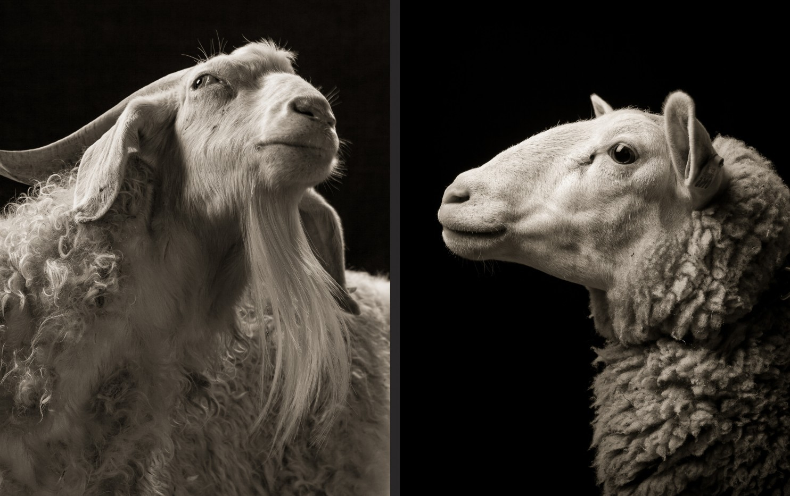
"Others I heal without medication. Much depends on humility and their tendency to pride as to how I will help them. That’s entirely different than recreational drugs, which are harmful to the soul and body, and do lead to witchcraft, and a way to escape from the realities of life which are painful but must in the long run be overcome with My help.

"There is no excuse for laziness. I am standing by to help you, dear one. I am begging you to begin to respond to Me before you stand before the Judgement Seat and have to give an accounting to Me for the gifts of life I gave you. You consumed food, air, electricity, other peoples time, and more things that I can mention. I provided those things to help get you on your feet. But you stopped at your comfort zone and settled in on your couch. Thickening on your lees. You will be called to account for how you used all the resources I set at your disposal so you could serve Me.

"There will be NO excuses, because I see through excuses to the core issue. So I am here now presenting you with a picture of what will happen at the Judgment Seat if you lived only for your own comforts and did very little to serve Me.

“When the Son of Man comes in his glory, and all the angels with him, then he will sit on his glorious throne. Before him will be gathered all the nations, and he will separate people one from another as a shepherd separates the sheep from the goats. And he will place the sheep on his right, but the goats on the left. Then the King will say to those on his right, ‘Come, you who are blessed by my Father, inherit the kingdom prepared for you from the foundation of the world.

“Then he will say to those on his left, ‘Depart from me, you cursed, into the eternal fire prepared for the devil and his angels. For I was hungry and you gave me no food, I was thirsty and you gave me no drink, I was a stranger and you did not welcome me, naked and you did not clothe me, sick and in prison and you did not visit me.’ Then they also will answer, saying, ‘Lord, when did we see you hungry or thirsty or a stranger or naked or sick or in prison, and did not minister to you?’ Then he will answer them, saying, ‘Truly, I say to you, as you did not do it to one of the least of these, you did not do it to me.’ And these will go away into eternal punishment, but the righteous into eternal life.” Matthew 25:31-34, 41-46

Wow! That's definitely a hard condemnation. And I wanted to mention, we raised sheep and had a few goats. And the goats were always butting the sheep. They were very aggressive. And the sheep were always mellow. There was just a whole different atmosphere about the sheep from the goats. The goats would just butt their way in, push their way in. Get to the feed before the sheep. And they'd start trouble. So, there's quite a bit about goats.

At this point, I really felt I needed to ask the Lord a question. So I said:

'Lord, we have some on the Channel who just don’t know what to do for You. They are drifting and the enemy paints them with condemnation because they haven’t been able to hear Your will for their lives. What about them?'

Jesus continued, “My people, it is a matter of heart attitude. This is what I wish for those of you who do not have specific tasks. When you see suffering or injustice, do what you can to help the victim.

"Did someone’s house burn down or was it flooded? Do you have a storage room with all kinds of things you’ve been hanging on to? Do you have recreational money that isn’t dedicated to absolute necessity? Give until it hurts. Do not let yourself pass by that person without reaching out to them.

"I will stir your heart. It may be a child at school that has no winter boots or coat. It may be a mother suffering from sickness and unable to clean her house or cook proper meals. It may be an elderly person suffering from loneliness and malnutrition. All of these are opportunities to go about doing good, as is written about Me.”

And that's Acts 10:37-39a You, yourselves know what has happened throughout Judea, beginning in Galilee with the Baptism John proclaimed. How God anointed Jesus of Nazareth with the Holy Spirit, with power. And how Jesus went around doing good and healing all who were oppressed by the devil, because God was with Him. We are witnesses of all that He did, both in the land of the Jews and in Jerusalem.

And we may not all be able to deliver people from demonic infestations, but we can certainly stop and give someone on the roadside a bottle of Gatorade and a sandwich. It all depends on your heart, where you are at in your heart. That's a very little thing, but it shows the kindness of the Lord.

This is the thing: in the church people would rather proselytize and preach and point out sins than just to give lovingly, unconditionally and allow that person to discover Jesus in you. When people discover how sweet and loving He is, they want to give their lives to Him. But they'll never discover it, if all we do is preach to them, and tell them what their sins are and how to be saved. They'll get saved alright, when they get a whiff of Jesus. They'll get saved.

But the other thing gives them whiff of the Pharisee and it turns people off. So, if you have a little bag in your car, as you go about your errands. And it has little bags to give to people on the street that are maybe panhandling for money, or looking for work. It's a beautiful thing to do. That's one little thing you can do. That's a time when the Lord will say, "Blessed are you, because you fed Me." And you'll say to the Lord, "When did I feed you?" And He'll bring up that situation where you stopped for a person on the street who had nothing to eat or drink. And you reached out and blessed them in Jesus' Name.

The Lord continued, "A mission or vocation from Me is a precious, precious gift to those whose hearts are well disposed. You begin by showing the disposition of your heart when you reach out to others to lessen their burdens. I see that and guide you deeper into selflessness, eventually blessing you with your mission, something perfectly fitted to you from your conception.

"I do not want you to ignore your family or sacrifice what is needed by them. I want you to bring your family along in works of mercy and charity. I will never give you so much to do that you become disordered in providing for your family.

"Perhaps you teach piano and a poor child really wants to learn but her family cannot pay you - and she doesn’t even have a piano. Take her on as a student, loan her a keyboard and if she shows promise, let her continue to use it. It may be that if you give her the keyboard her parents will sell it for food or medicine, they're so poor…so you keep it on loan."

By the way. That was the situation with me. I really, really wanted to play the piano when I was younger. Gosh, grammar school, freshman, sophomore years I really wanted to play the piano. But I didn't have one, and my mother didn't have the money to buy me one. And keyboards hadn't been invented yet. How much different would my story be if the music teacher had taken me under her wing and supplied me with a piano or time to play a piano and given me free lessons?

The Lord continued here, "Be creative."

I mean, here I am in my 70's just starting out with music. You know - just imagine what it would have been for me if I had caught on to it when I was much younger.

The Lord continued, "Be creative and listen for the sweet voice of My Spirit making suggestions that bathe your heart in warmth. That’s how I will lead you. Baby steps, leading you from the feeling of compassion in your heart into doing something about it.

"Start small and be faithful. Eventually, you will instinctively know you are to help certain people or not help them. You can even use your Bible Promises. But remember, I am whispering in your heart to reach out and give. As you learn to obey these promptings, you will get clearer and clearer leadings and I will graduate you into greater callings until you are firmly established in your lifelong mission.

"Be faithful in the little things, My dear ones. Then at the Judgment, you will be among the sheep: “‘Come, you who are blessed by my Father, inherit the Kingdom prepared for you from the foundation of the world.”

